

Draw It or Lose It – Web Edition

CS 230 Project Software Design
Version 1.0

Table of Contents

CS 230 Project Software Design Template 1
Table of Contents 2
Document Revision History 2
Executive Summary 3
Requirements 3
Design Constraints 3
System Architecture View 3
Domain Model 3
Evaluation 4
Recommendations 5

Document Revision History

Version | Date | Author | Comments
1.0 | 11/10/25 | Brian Minor | Completed full draft including Executive Summary, Requirements, Design Constraints, Domain Model, Evaluation Table, and Recommendations. Added UML diagram and formatted document.

Executive Summary

The Gaming Room (TGR) will expand its Android-only title, Draw It or Lose It, into a browser-accessible, multi-platform experience. The solution adopts a clean domain model (Game, Team, Player) that derives from an Entity base class and uses two key patterns to meet requirements efficiently: (1) Singleton for GameService so only one orchestrator instance exists in memory, and (2) Iterator to scan in-memory collections and enforce unique names for games, teams, and players before creation. This prototype demonstrates the constraints and behavior required now, while keeping the design ready for a stateless web API and future database-backed persistence.

Requirements

Business requirements: (a) Support one or more teams per game; (b) Each team has multiple players; (c) Game and team names must be unique so users can check availability; (d) Only one instance of the game service should exist at a time. Technical requirements: Implement a single orchestrator (GameService) via Singleton; use Iterator-based searches to guarantee name uniqueness; centralize id generation for Game/Team/Player; provide a runnable Java prototype (ProgramDriver) to verify behavior.

Design Constraints

Business requirements: (a) Support one or more teams per game; (b) Each team has multiple players; (c) Game and team names must be unique so users can check availability; (d) Only one instance of the game service should exist at a time. Technical requirements: Implement a single orchestrator (GameService) via Singleton; use Iterator-based searches to guarantee name uniqueness; centralize id generation for Game/Team/Player; provide a runnable Java prototype (ProgramDriver) to verify behavior.

System Architecture View

No system architecture components are required for this project per the assignment guidelines.

Domain Model

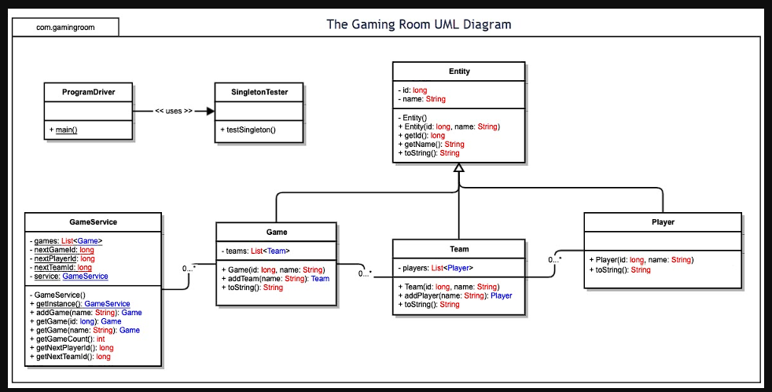

The UML shows Entity at the top with id and name. Game, Team, and Player inherit from Entity (Inheritance) and expose read-only identity (Encapsulation). ProgramDriver uses GameService (a Singleton) to add/find entities. GameService uses Iterator over internal collections to enforce unique names before instantiation. This model satisfies: multiple teams and players, unique names for games/teams/players, and a single orchestrator.



Evaluation

Using your experience to evaluate the characteristics, advantages, and weaknesses of each operating platform (Linux, Mac, and Windows) as well as mobile devices, consider the requirements outlined below and articulate your findings for each. As you complete the table, keep in mind your client’s requirements and look at the situation holistically, as it all has to work together.

In each cell, remove the bracketed prompt and write your own paragraph response covering the indicated information.

Development Requirements | Mac | Linux | Windows | Mobile Devices
Server Side | Linux: The strongest option for hosting the web-based backend due to stability, scalability, container support (Docker/Kubernetes), strong security hardening, and low licensing cost (free/open source). Highly supported by all major cloud providers.  Mac: Capable of running server software but not commonly used in enterprise production environments. No dedicated server SKUs, higher hardware cost, and limited scalability make it unsuitable for large-scale hosting.  Windows: Fully capable as a server platform using IIS or Java-based stacks. Licensing fees increase cost of ownership, but integration with Active Directory and strong enterprise tooling are advantages.  Mobile Devices: Cannot host backend services. Mobile platforms serve only as clients. The backend must be hosted on Linux or Windows servers. | De facto standard for servers. Excellent package ecosystem, container support, observability, and security hardening. Broad cloud vendor support and lower TCO. Strong choice for scalable web back ends. | Well-supported in enterprises; IIS/.NET strong, Java also supported. Licensing cost and heavier footprint compared to Linux. Operational tooling is mature; works well where AD/Windows integration is required. | Not appropriate to host the server back end. Mobile acts as client only. Use HTTPS to a Linux/Windows server or managed cloud platform.
Client Side | Linux/Mac/Windows: Desktop support is achieved through a standards‑compliant, responsive HTML web client. Ensuring cross‑browser compatibility (Chrome, Safari/WebKit, Firefox, Edge) is essential. Testing must confirm identical behavior across platforms. No native desktop application is required, reducing cost and development time.  Mobile (Android/iOS): A responsive web application will run in mobile browsers with minimal additional cost. However, native mobile apps (optional) require separate development work in Android Studio and Xcode. Testing across screen sizes, touch interactions, and mobile performance must be included in the development process. | Client is usually a browser on desktop Linux; standards-based web app covers it. Native desktop client uncommon; cost/time saved by targeting web. | Largest desktop base; test on Chromium/Edge and Firefox. Native Win client optional; web app reduces cost and speeds delivery. | Primary client target alongside desktop web. Responsive web app first; native Android/iOS later if needed for notifications/offline/graphics.
Development Tools | Linux/Mac/Windows: Server‑side development uses Java 17+, Spring Boot, Maven/Gradle, IntelliJ IDEA or VS Code, JUnit, Postman, and Docker/Kubernetes for deployment. These tools are available on all desktop platforms. Most tools are free or offer free community editions. Multiple teams may be needed if native desktop clients were ever added; however, a browser‑based solution allows a single full‑stack team.  Mobile: Native development requires Android Studio (free) for Android and Xcode (free but requires macOS hardware) for iOS. Web development for mobile uses the same toolchain as desktop web. Testing tools include browser dev tools, emulators, and device testing. | Same toolchain; CI/CD and Docker/Kubernetes are first-class. Package managers and systemd ease service management. | Same Java toolchain; WSL2 or native Docker Desktop; Visual Studio Code/IntelliJ. IIS optional if serving static assets; otherwise reverse proxy via Nginx/Apache. | For native: Android Studio/Xcode. For web: any modern JS framework; testing on Chrome/Safari mobile.

Recommendations

- Operating Platform:
The recommended operating platform for hosting Draw It or Lose It is Linux. Linux provides high reliability, scalability, and performance for web-based applications while maintaining a low total cost of ownership due to its open-source licensing model. Linux is the dominant server platform across cloud providers and supports containerization and distributed deployments, making it well suited for expanding the application to multiple computing environments.

- Operating Systems Architectures:
Linux uses a modular UNIX-based architecture consisting of a monolithic kernel, system libraries, and user-space applications. The kernel is responsible for process scheduling, memory management, device drivers, and networking. This architecture supports multi-user and multi-threaded workloads, allowing Draw It or Lose It to run as stateless web services that can scale horizontally across multiple servers behind a load balancer.

- Storage Management:
A relational database management system such as PostgreSQL or MySQL is recommended for persistent data storage. These systems provide transactional consistency, indexing, and concurrency control for managing games, team, and player data. Static assets, such as drawing images, should be stored in object storage and delivered through a content delivery network (CDN) to reduce server load and improve response times.

- Memory Management:
Linux uses virtual memory and paging to efficiently allocate physical memory across processes while maintaining isolation and system stability. For the Draw It or Lose It application, the Java Virtual Machine manages heap allocation, garbage collection, and thread stacks. Linux complements this by scheduling processes and managing memory resources to support thousands of concurrent users.

- Distributed Systems and Networks:
Draw It or Lose It operates as a distributed web application using RESTful APIs over HTTPS. Client devices communicate with backend services through load balancers that distribute traffic across multiple instances. Shared databases and caching systems support coordination between services. Network dependencies such as latency and outages are addressed through redundancy, monitoring, retries, and fault-tolerant design.

- Security:
User information is protected using layered security controls. Transport Layer Security (TLS) encrypts data in transit, while database encryption protects data at rest. Authentication and authorization are handled using OAuth 2.0 and role-based access control. Linux security features, including file permissions, firewalls, and container isolation, further protect the application from unauthorized access.

